Execute Jenkins Job



This section will guide you on:

* How to build Jenkins job with Cucumber

**Development Environment:**

* JRE: OpenJDK Runtime Environment 11.0.2
* Maven path setup
* Eclipse IDE for Enterprise Java Developers v2019-03 (4.11.0)
* Jenkin war file

This guide has two subsections, namely:

* Executing through Jenkins
* Pushing the code to your GitHub repositories

Executing through Jenkins

* Login into Jenkins

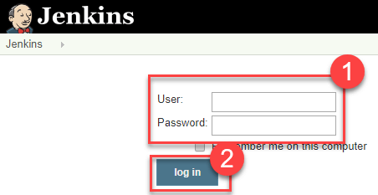

* Create a new job as Maven Project

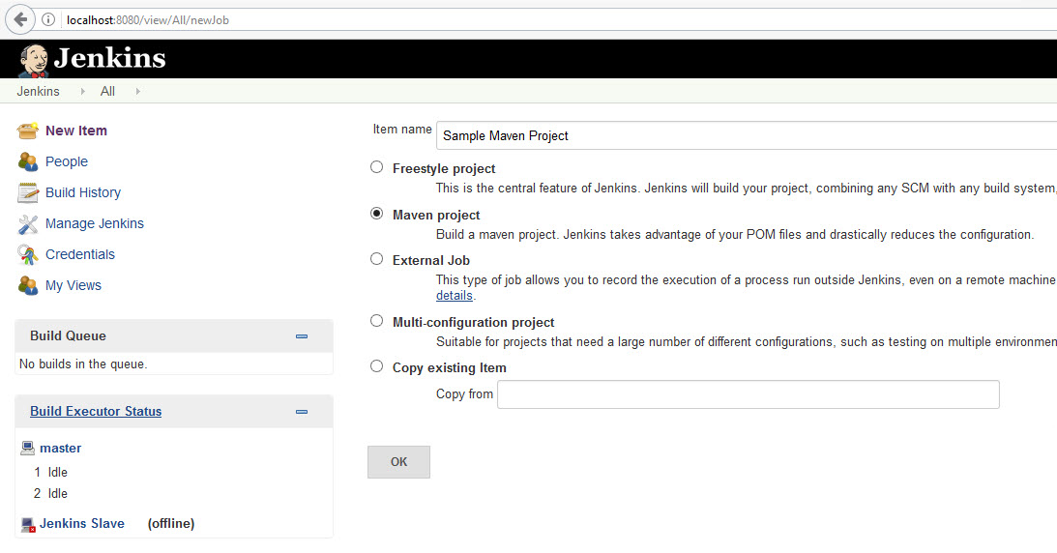

* After then click on the created projected from the Jenkins Dashboard and click on “Configure”.
* In Job Configuration, go to the “Build” section and provide the path of pom.xml which has to be executed.
* And click on “Save” and click on “Build Now” to start the execution on Jenkins.

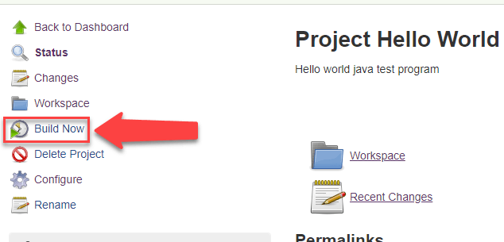

* After Executing the build, you can review the result as below:

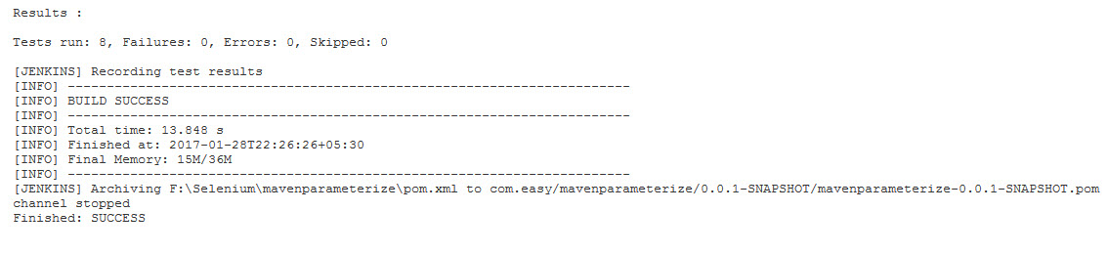

* Pushing the code to GitHub repositories

Open your command prompt and navigate to the folder where you have created your files

cd <folder path>

Initialize your repository using the following command:

git init

Add all the files to your git repository using the following command:

git add .

Commit the changes using the following command:

git commit . -m “Changes have been committed.”

Push the files to the folder you initially created using the following command:

git push -u origin master